Using Microsoft Excel as a Data Science Tool

Wade Eckert
Bellevue University
DSC 101: Introduction to Data Science
Dr. Shawnee Mansfield
April 5, 2025

Using Microsoft Excel as a Data Science Tool

To clean the data in the concessions Excel file, I started by fixing the values in the “Date” field. To do this, I formatted everything in the “MM/DD/YYYY” format and then fixed any values that had “.” Instead of “/” in them. I also corrected any inconsistent data types and changed them to the correct value (Example: 1/41/2022 changed to 1/4/2022 and 1/3/2023 changed to 1/3/2022). Once all the dates were in the proper format, I proceeded to group the item names and category names in pivot tables using the insert pivot table function to find any fields incorrectly spelled. Once all these data fields were corrected and spelled correctly, I looked for any missing or inconsistent values in the “Sale Price” field. I formatted all these values into a currency value. Then, I added in any missing values by matching them with other concession sales of that type of item (since sales of each item are consistent).
To calculate the various profit calculations, I started by making another column for the actual profit of each line item. I did this by using a “VLOOKUP” function that referenced the values from the “Item Look Up Table” sheet and subtracted this referenced amount from the actual sale price of the item from the original table in “Sales Transactions.” I then made two tables for profits: one for profit for each day and one for profit for each sale item. I then used the “SUMIFS” function in these tables to sum the profits from each sales day and sale item. I then calculated the percentage of sales by day and by item.
Based on the information from these tables, I could answer various questions based on the actual profit. That total actual profit for all items sold ended up being $323. Please see the tables below for profit per day in dollars, total profit in total, and the profit per item in dollars.
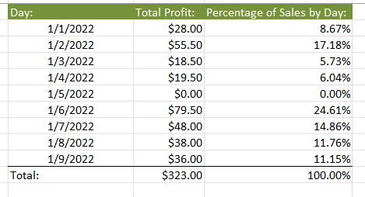
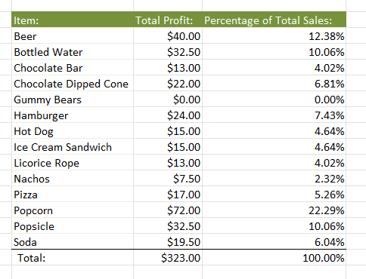
According to the tables I made, the most profitable item was popcorn, which made $72 profit and 22.29% of total sales. The next most profitable item was beer, which made $40 profit and 12.38% of total sales. The next two most profitable items were bottled water and popsicles, each making $32.50 profit and 10.06% of total sales. Every other item made less than 7.5% of total sales. The least profitable items were gummy bears, which broke even due to the sale price being the same as the cost of goods. Possibly, gummy bears are being used as a loss leader. If not, the concession owner should consider raising the sale price of gummy bears. Every other item made a profit. Nachos made a particularly low profit at $7.50 or 2.32% of total sales.
The most profitable day was 1/6/2022, with $79.50 profit and 24.61% of total sales. The next most profitable day was 1/2/2022, with $55.50 in profit and 17.18% of total sales. The least profitable day was 1/5/2022, with $0 in total sales. I assume this is due to the concession stand not being open on that particular day. If not, the owner should consider looking into why they had no sales on that day. Every other day made some profit. Although 1/1, 1/3, and 1/4 had particularly low sales on these days, with 8.67%, 5.73%, and 6.04% of total sales, respectively.
Next, I made another column for “Calories” and used the “VLOOKUP” function to reference the caloric number from the “Item Look Up Table” sheet. Then, I made the same tables I made for profit but for total calories instead. From these tables, I calculated that all sales' total amount of calories was 50,670. Please see the tables below for the total calories per day and total calories per sale item.
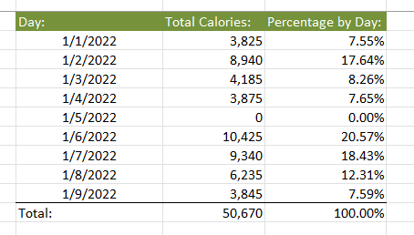
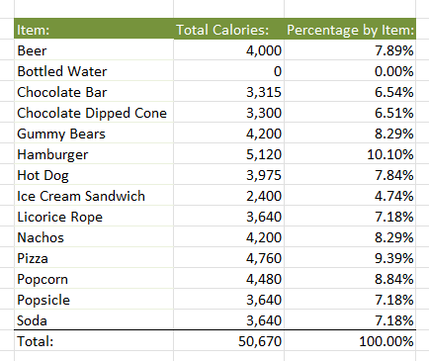
According to the tables, 1/6, 1/7, and 1/2 had the highest total caloric content sold, with 10,425 or 20.57%, 9,340 or 18.43%, and 8,940 or 17.64%, respectively. Again, 1/5 had the least caloric content, totaling 0. This could be because of the same reasons as the profit, but this is an assumption based on the data. Other than 1/5, the days with the least caloric content would be 1/1, 1/3, 1/4, and 1/9. The totals and percentages on these days were 3,825 or 7.55%, 4,185 or 8.26%, 3,875 or 7.65%, and 3,845 or 7.59%, respectively.

References
Wheelan, C. (2013). Naked Statistics: Stripping the Dread from the Data. W.W. Norton & Company.

